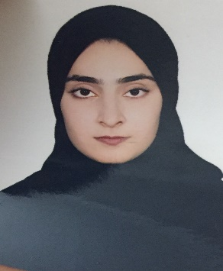CURRICULUM VITAE

FOUZIA A.KHALIL EBRAHIM

M0B: 33047955/39828741

# EMAIL ID: foziabaloch95@gmail.com

# Belding: 640, Flat No:12, Road:1712, Riffa Bukawara:917

# Kingdom of Bahrain.

# OBJECTIVE



Seeking a challenging and responsible role in the field, where my skills and abilities could be best utilized to their frill potential and can grow professionally.

# PERSONAL DETAILS



Date of birth : 23-05-1995

Nationality : Bahraini

Sex : Female

Marital Status : Married

Religion : Muslim

CPR No : 950509663

# QUALIFICATION



* + 2018 BSC — Accounting & Marketing from university of Bahrain, Bahrain.
  + 2013 Secondary School certificate form West Riffa Secondary School, Bahrain.

JOB EXPERIENCES



|  |  |
| --- | --- |
| * Period: | July 201 8 —August201 8 |
| * Position: | secretary |
| * Company: | In University of Bahrain (English Department) |

# LANGUAGES KNOWN



* Arabic
* English
* Urdu
* Balochi

DRIVING LICENSE



* Having a Valid Light Vehicle Driving License in Bahrain

DECLARATION



* I declared that the above side details are true and correct to the best of my knowledge.

FOUZIA ABDULKHALIL